1. Create A Table

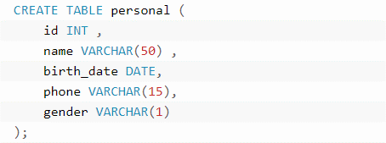

1. Insert data into table

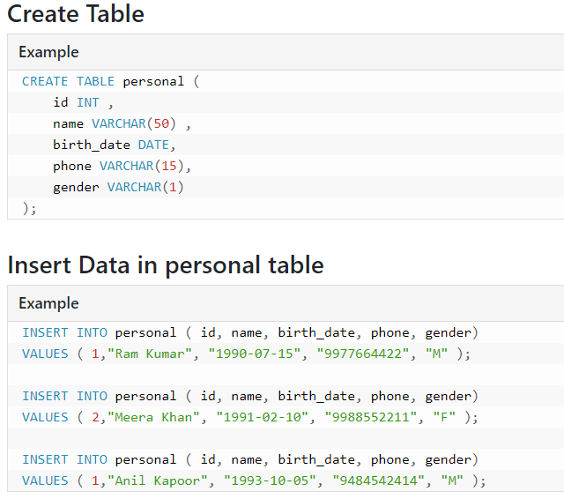

1. Make Some constraints on our table

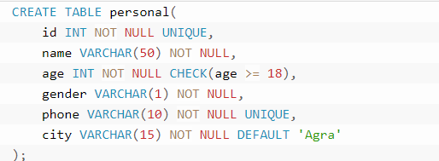

Isme Id null ni hgi and and whi data save hga jisme age >=18 h

1. Select and where clause

